USB-Fm-Transmitter 0,15 Watt  Radio is a amazing simpel medium. Just some electronic components are enough for transmitting a radioshow. The small USB-FM-Transmitter transforms your computer into a relay station. It can pick up any audio signal from your computer and send it over the UKW-band. (ultrashort wave)  This transmitter is module for a emancipatory society.  How to  Our selfmade circuit board has now holes. All components get soldered on the board. See the example.  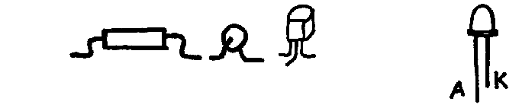  Attention:  The two transistors and the LEDs have a polarity! Take care how the transistors are placed on the layout. Cut first the +(positiv =A) longer leg of the LED and solder it and then cut the and solder the shorter second leg (- =K)  The stereo NF-connection cable must be transferred into mono cable by bridging the wires. Means you have to hot-wire the red and the white wire by twisting the ends together after you have remove insulation before.  Twist also copper part together. Its the ground part.  After soldering all parts and connecting the board with your computer the red LED should glow. Then you try to find a frequency on your variable capacitor. Don't take a metal part for spinning around. Take something wooden or cardboard. | 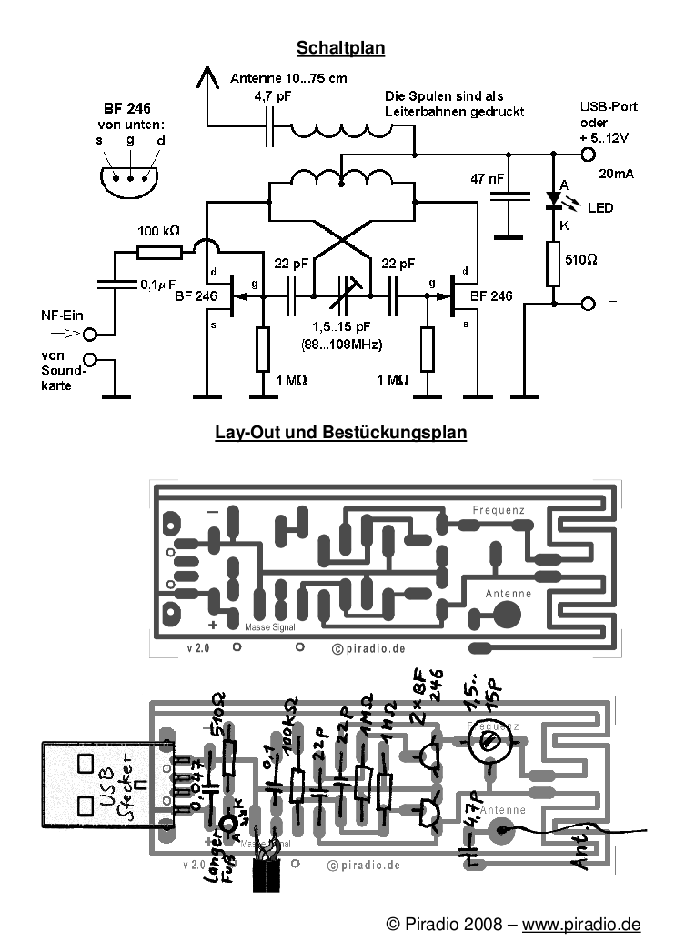
  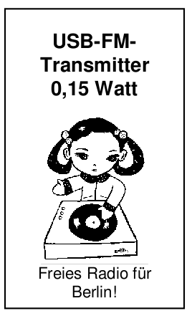 | Parts-List  1 x 520 Ω (green-brown-brown)  1 x 100 kΩ (brown-black-yellow)  2 x 1MΩ (brown-black-green)  1 x capacitor 0,1µF (0,1)  1 x capacitor 47 nF (0,047)  1 x capacitor 4,7pF (479)  2 x capacitor 22pF (22)  1 x variable capacitor 1,5 15pF  2 x transistors BF246 (F246A)  1 x LED red  1 x NF-connection (mini-jack)  1 x USB for power connection

What to bring
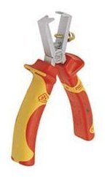
 | Cabel striper
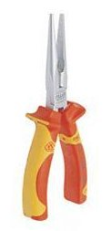 | long nose pliers – holding parts
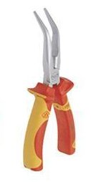 | This kind of plier – for cutting and holding parts
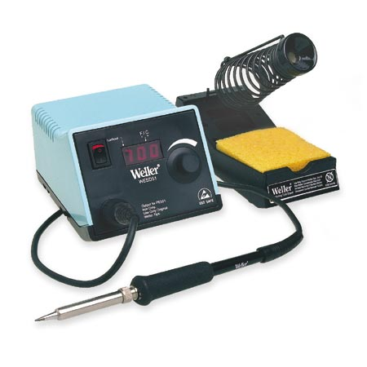 | Solder Station – please tell us if you need one if you don't have
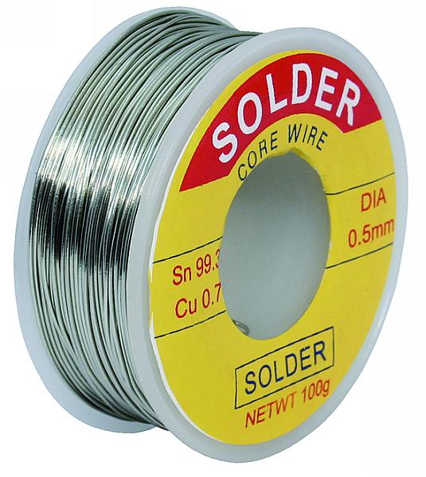 | Solder – will be also there
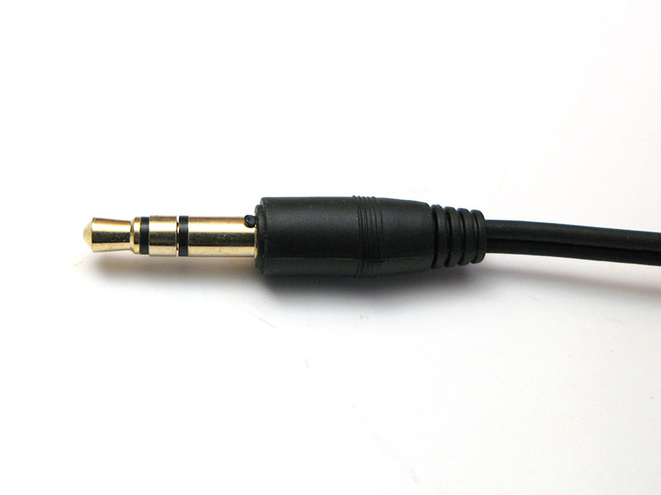 | Mini-Jack – you can recycle one!
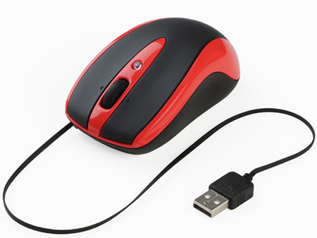 | We just need the USBconnector you can recycle one of this size.
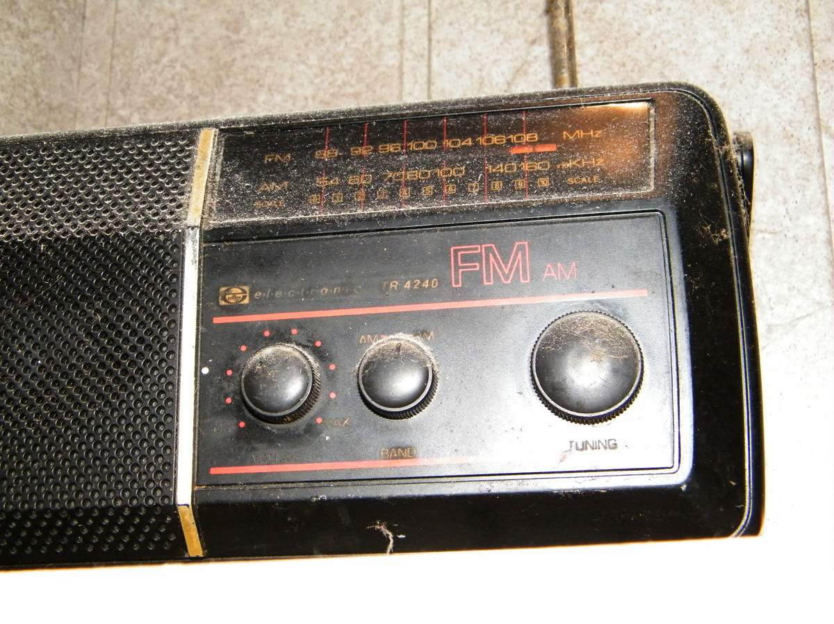 | FM-Radio
Laptop | You can bring as well your own laptop to test.

